BDA - EXP - 3 Word count program using map reduce

Atharva Pawar - 9427 - [Batch - D]

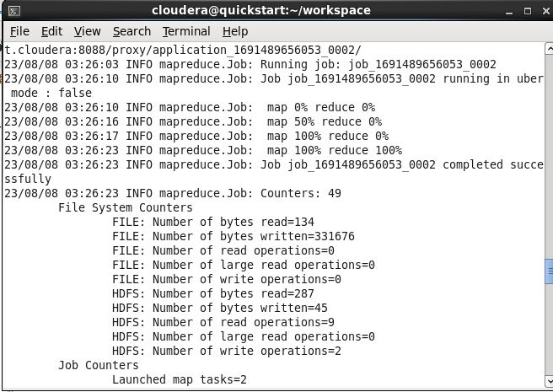

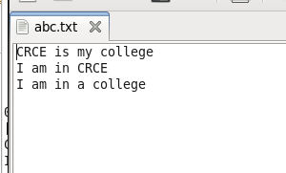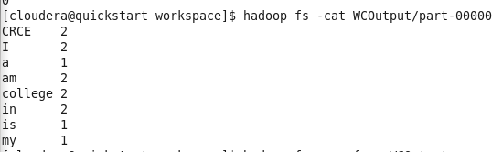

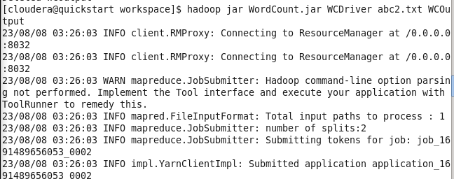

hadoop fs -put WCFile.txt WCFile.txt

hadoop jar WordCount.jar WCDriver WCFile.txt WCOutput hadoop fs -cat WCOutput/part-00000

